Cecilia Moreno

Env. Sci. 2

Statistics in the news

10/13/20

Police Brutality and Violence Against the Black Community

This year has been filled with a plethora of data and information. Whether it be information bias, mis-information, or essential information. I, alongside many Americans, have learned that not all information can be trusted. One event that sparked an uproar in our society was the killing of George Floyd by a brutal police officer. I, like many Americans, for most of my life believed that police were supposed to “protect and preserve” our rights. When this unbearable event was broadcast on the news, I started to question that belief. Protests started to happen all around Orlando, and I wanted to know how I could help be a part of this movement. So I helped the only way I knew how. I informed myself.

Before I decided to go to one of the protests for Black Lives Matter, I needed to do my research so that I knew and understood what I was marching for. I looked everywhere for all sources, news, articles, books, videos etc… and the evidence was overwhelming that what happened to George Floyd was not an isolated incident. About 1,000 civilians are killed each year by law enforcement officers. It is estimated that black men are 2.5 times more likely than white men to be killed by police during their lifetime. Another study says that black people who were fatally shot by the police are twice as likely than white people to be unarmed data taken from California shows that police stopped and used force against black people disproportionately more than any other racial group. Police records tend to underestimate the levels of racial bias in their policing, even covering up discrimination entirely. Tracey Meares, founding director of the justice Collaboratory at Yale Law school in New Haven, Connecticut says “I hope when people think of the science of this that they understand what we know , what we don't know and why we don't know it.”

The Black Lives Matter movement is a movement that has been highlighting this issue for a very, very long time. Amaud Aubrey, Breana Taylor, and so many more names are chanted in remembrance of them and the number of killings the police have just been able to get away with. This data has only come up in recent years because people have checked the facts. This goes to show you that police officers who kill almost never face the consequences the rest of us citizens have to face.For the first time in thirty five years a Chicago police officer was charged with first degree murder after the death of Laquan McDonald on October 20th, 2014. Out of 1,944 police killings of black people from 2013 to 2019, charges were brought against police officers in 3% of the cases. Fewer than 1% of police killings reached a conviction.

People tend to overestimate black involvement in crime. This creates a bias in police officers that scientists now are looking into. The chart bellow is a national sample the Pickett ET AL, Criminology took in 2011 recording what percentage of crime people believe is caused by black Americans and what that percentage really is. People believe that about 40% of break ins are caused by black Americans, but the true number is 31.7% of all break ins are by black Americans. The statistic shows that people believe that 43% of gun point robbery is by the black community. In actuality it is 42% and so on. The black community makes up about 13% of the US population, but they still end up 31% of police brutality victims according to a study done by the FBI in 2012.

The evidence is overwhelming and when I started to dive deeply into this subject, I couldn’t help but cry for the fact that my friends and some of my family have to walk outside every day with the threat that they are already targeted by a killer who can get away from their crime. I am glad that scientists and fact checkers are getting involved because then it can be proven. This is not a political issue, with sides for or against. This is a human rights issue, and everyone should be behind the facts.

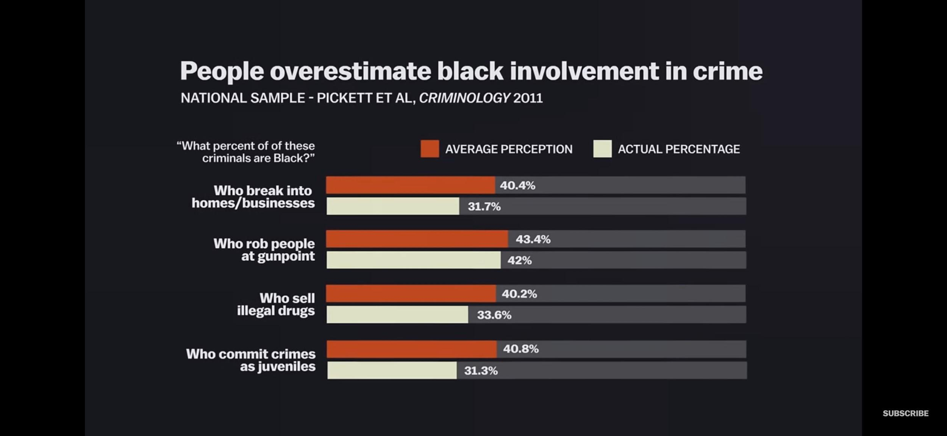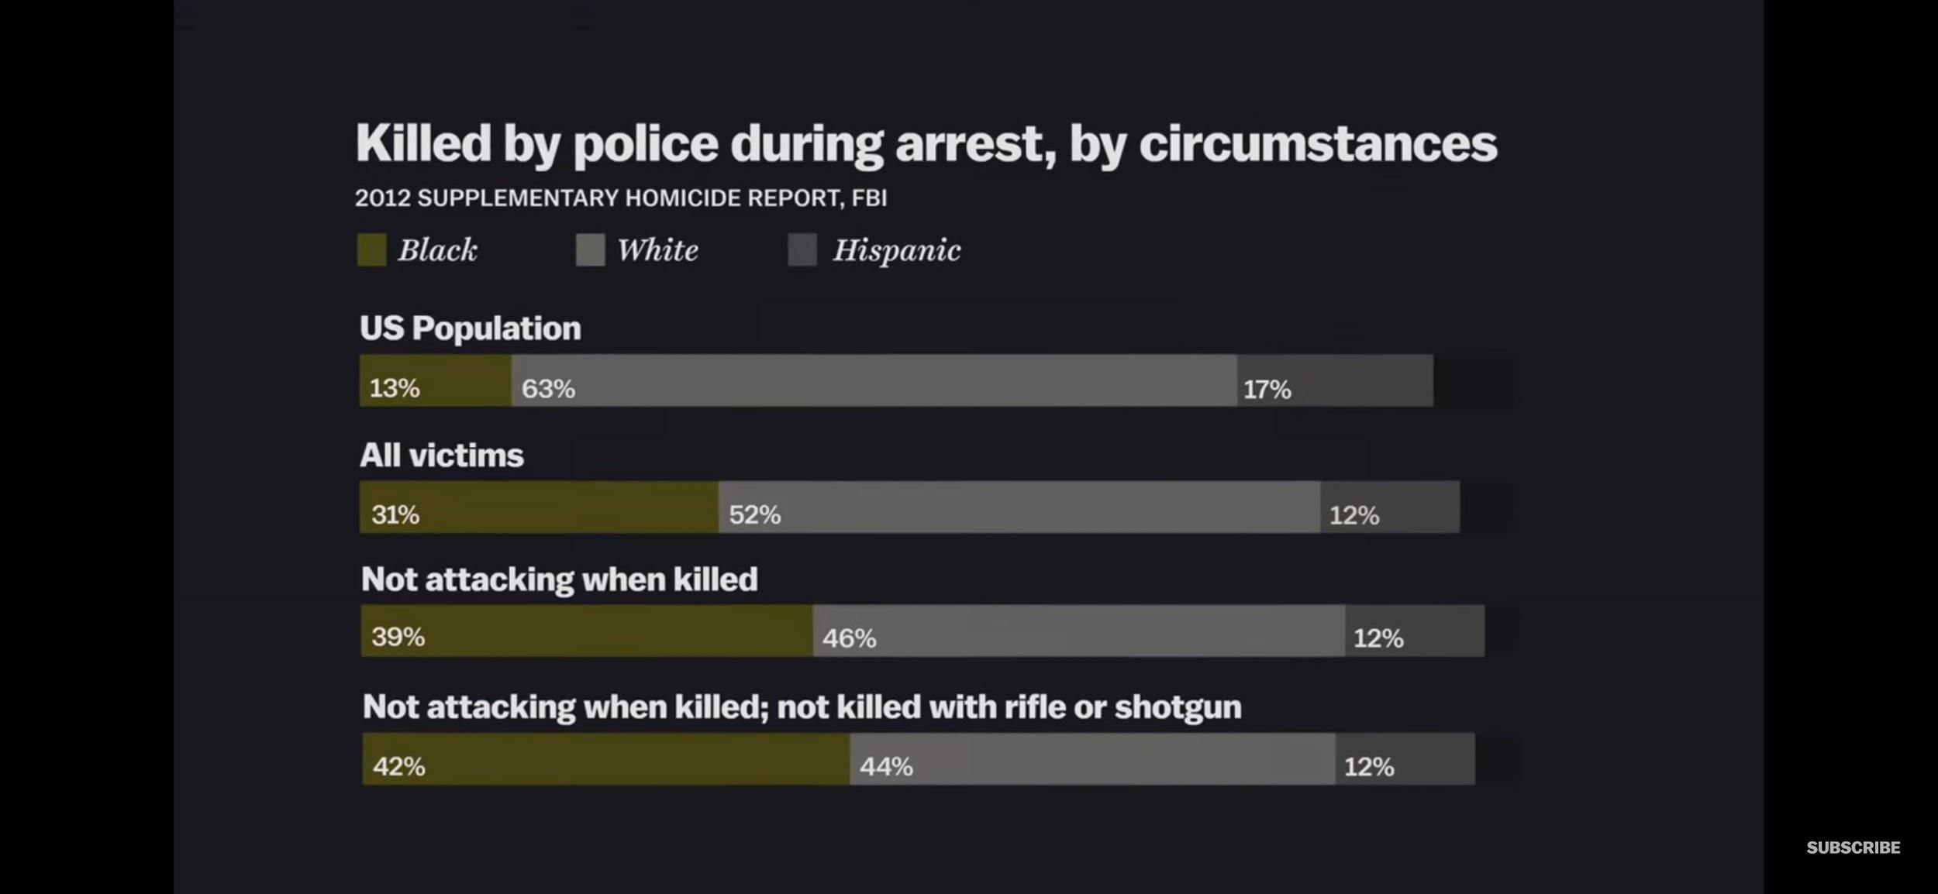

Works Cited

<https://youtu.be/0-4Gb_0_kR0>

<https://youtu.be/8RYdItBIuOU>

<https://www.nature.com/articles/d41586-020-01846-z>

<https://youtu.be/OCBwjFFpNik>